DBMS LAB ASSIGNMENT – 2
Name :- Parth Bhayani Prn No :- 26070122512 Batch:-B3
Title :- Introduc on to DDL and DML Commands and its execu on
Descrip on :-
Data defini on language defines the schema for the database by specifying en es and the rela onship among them. In addi on to this, DDL even defines certain security constraints.The execu on of DDL statements results in new tables which are stored in "system catalog" also called data dic onary or data directory.
Data Manipula on Language is a language that provides a set of opera ons to support the basic data manipula on opera ons on the data held in the databases. It allows users to insert, update, delete and retrieve data from the database. Data manipula ons are applied at internal, conceptual and external levels of schemas. However, the level of complexity at each schema level varies from one another.
Data Control Language statements control access to data and the database using statements such as GRANT and REVOKE. A privilege can either be granted to a User with the help of GRANT statement. The privileges assigned can be SELECT, ALTER, DELETE, EXECUTE, INSERT, INDEX etc. In addi on to gran ng of privileges, you can also revoke (taken back) it by using REVOKE command.
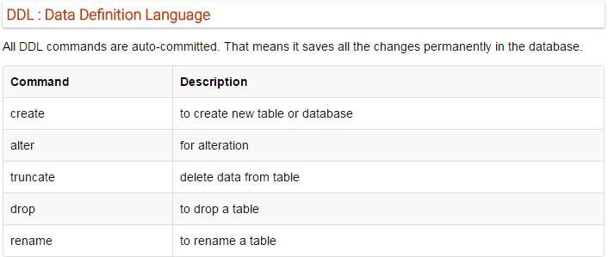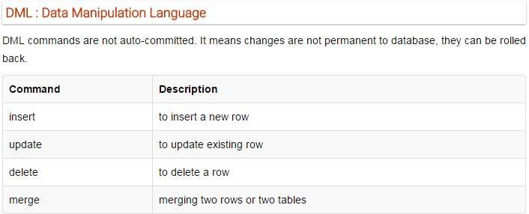
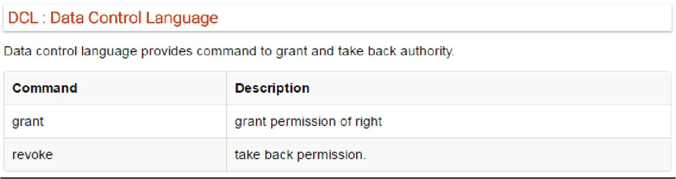

Assignment -2 Lab Ques ons Sec on – 1 DDL Commands
Q1 :- Explain DDL commands and their syntax ?
Ans :-
DDL (Data Defini on Language)
DDL (Data Defini on Language) is a set of SQL commands used to create, modify, and delete the structure of database objects such as databases and tables.
Common DDL Commands
1. CREATE
Purpose: Creates a new database, table, view, or other database object.
Syntax (Create Database): CREATE DATABASE database_name;
Example:
CREATE DATABASE LibraryDB; Syntax (Create Table): CREATE TABLE table_name ( column1 datatype, column2 datatype,
...
);
Example:
CREATE TABLE STUDENT (
Stuid INT PRIMARY KEY,
Sname VARCHAR(50),
Email VARCHAR(100)
);

2. ALTER
Purpose: Modifies the structure of an exis ng table.
Syntax (Add Column):
ALTER TABLE table_name ADD column_name datatype;
Example:
ALTER TABLE STUDENT ADD Phone VARCHAR(15); Syntax (Modify Column):
ALTER TABLE table_name MODIFY column_name datatype;
Example:
ALTER TABLE STUDENT
MODIFY Sname VARCHAR(100);
Syntax (Drop Column):
ALTER TABLE table_name DROP COLUMN column_name;
Example:
ALTER TABLE STUDENT
DROP COLUMN Phone;

- DROP
Purpose: Permanently deletes a database or table along with all its data.
Syntax (Drop Table): DROP TABLE table_name; Example:
DROP TABLE STUDENT;
Syntax (Drop Database):
DROP DATABASE database_name;
Example:
DROP DATABASE LibraryDB;

- TRUNCATE
Purpose: Deletes all records from a table but keeps the table structure.
Syntax:
TRUNCATE TABLE table_name; Example:
TRUNCATE TABLE STUDENT;

- RENAME
Purpose: Changes the name of a table.
Syntax:
RENAME TABLE old_table_name TO new_table_name;
Example:
RENAME TABLE STUDENT TO STUDENTS;
Q2 :- Create tables for the following rela onal model of library management. Apply constraints on the columns and also alter the structure according to your requirements.
    - SIULIBRARY (Slid,lname,loca on,noo ranches)
    - Ilibrary(Lid, lname, city, area, slid)
    - BOOKS(Bid, Bname, Price , Lid)
    - Noofcopies(bnid,bid,blid)

    - AUTHOR(Aid, Aname,email,phoneno)

    - Writes(Bid, Aid, pid)

    - PUBLISHER(Pid, Pname)
    - SELLER(Sid, slname, city)

    - DEPARTMENT (Dep d,deptname, Iname,lid)

    - STUDENT(Stuid, Sname, email,memid dep d)

    - STAFF(S d, stname, email, dep d,memid)

    - PURCHASE(prid , lid, sid, pid, bid, quan ty ,date, totalcost)

    - ISSUE(lssueid, memid, bid, lid, issuedate, returndate)

    - SELLS (sid, bid,pid)

    - Employee(eid,empname,email,salary,lid)

    - A_specializa on(spec_id,spec_name,Aid)

    - Member(emid,lid)
Sec on- 2 DML Command execu on
  - Explain DML commands and their syntax.
  - Insert 5 tuples in each of the created tables.
Q-2 Execute following queries on the library database

    - Which institute libraries are located in pune city?
    - To which institute CS department belongs to?

    - Find all the books whose price is between 800 to 12000?
    - Find out such employees who’s salaries are not greater than 50,000/-

    - Find out such sellers who’s name end with “ta”
    - Find out such ins tute libraries where their area informa on is missing.

    - Find out such staff members who’s name doesn’t starts with “A”
    - Find out such SIU libraries which have ins tute libraries located in Bangalore.

    - Which students belong to civil department?
    - Find out books which are wri en by “shru ” and published by Mcgraw hill ? Input and Output :-
